CLICKUP & HUBSTAFF INTEGRATION



Document ID | DEV-FIN-SOP-002-v1.0
Product | Finance
Environment | ---
Confidentiality Level | Internal / Restricted

CONTENTS
1 DOCUMENT INFORMATION 3
1.1 Validation 3
1.2 Document Distribution 3
1.3 Version Control 3
2 PURPOSE & CONTEXT 4
2.1 About this document 4
2.2 Scope 4
2.3 Roles & Responsibilities 4
2.4 Terminology 4
2.5 Conventions Used 5
3 CHECK HUBSTAFF INTEGRATIONS 6
3.1 Prerequisites 6
3.2 Linking projects 6
3.3 Unlinking projects 7
4 TRACK TIME IN HUBSTAFF 8
4.1 Use Hubstaff desktop to track your time 8
4.2 Know what’s being tracked 9
5 APPROVAL SIGNATURES 10

DOCUMENT INFORMATION

Validation
Name |  | Role | Date (dd/mm/aa)
Issued by | Oscar Rondon | Technical Writer | 09/01/2025
Verified by | Vishal Bavadiya | Developer
Approved by

Document Distribution
Normal | Role
Oscar Rondon | Technical Writer
Anthony Bures | Digital Development Manager
Vishal Bavadiya | Developer

Version Control
Version | Date | Author | Description of changes
1.0 | 09/01/2025 | Oscar Rondon | First version of the Clickup and Hubstaff integration - SOP document

PURPOSE & CONTEXT

About this document
This document explains how Hubstaff integrates with ClickUp within ZTERS. It provides guidance on linking ClickUp projects to Hubstaff, tracking time on assigned tasks, and understanding how tracked time is synchronized between both platforms.

Scope
This SOP applies to all ZTERS team members and contractors who are required to track time on ClickUp tasks using Hubstaff.
In scope:
- Linking and unlinking ClickUp workspaces and projects in Hubstaff
- Tracking time on assigned ClickUp tasks using the Hubstaff desktop application
- Understanding how time entries, task status changes, and activity data are reflected on both systems
Out of scope:
- Payment processes
- Invoice creation
- Approval workflows or configurations

Roles & Responsibilities
Role | Responsibilities
Contractor | - Link their ClickUp account with Hubstaff as instructed  - Track time accurately on assigned ClickUp tasks using Hubstaff  - Ensure the timer is started and stopped correctly  - Avoid completing tasks prematurely in Hubstaff if work is not finished
Project Manager | - Assign tasks in ClickUp so they are available in Hubstaff  - Review tracked time and activity information when needed
Administrators | Manage access permissions and integration settings

Terminology
Term Used | Description
Hubstaff | Time-tracking and workforce management platform used to log work hours and generate invoices.
ClickUp | A project and task management platform where ZTERS tasks are created, assigned, and tracked
Integration | The connection between ClickUp and Hubstaff that allows tasks and time entries to sync between both systems
Task | A unit of work created in ClickUp and tracked in Hubstaff for time and activity
Timesheet | Recorded time entries linked to tasks over a specific period
Activity Tracking | Hubstaff features such as screenshots, activity percentages, and app/URL usage that are recorded while the timer is running

Conventions Used
The following structures are used as recommendations.
Tip: A recommendation or useful advice

Warning: A warning or important notice

Note: A notice.

CHECK HUBSTAFF INTEGRATIONS
Hubstaff allows you to track time on ClickUp tasks and sync those time entries back to each task in ClickUp. The steps below show you how to integrate ClickUp with Hubstaff so your team can log time from the Hubstaff timer.

Prerequisites
- User has an active ZTERS Hubstaff account
- User has access to the correct ClickUp workspace
- Tasks are already assigned in ClickUp

Linking projects
- Go to your Hubstaff page
- Click your profile icon (top-right) and select Integrations.
- Search for and select ClickUp.
- Click Next to grant Hubstaff access to your ClickUp account. You will not be prompted if you are already logged into ClickUp.
- Choose the ZTERS ClickUp Workspace and select Connect Workspace.
Tip: If your ZTERS account has already been set up, you will see ZTERS, Inc in the organizations list.

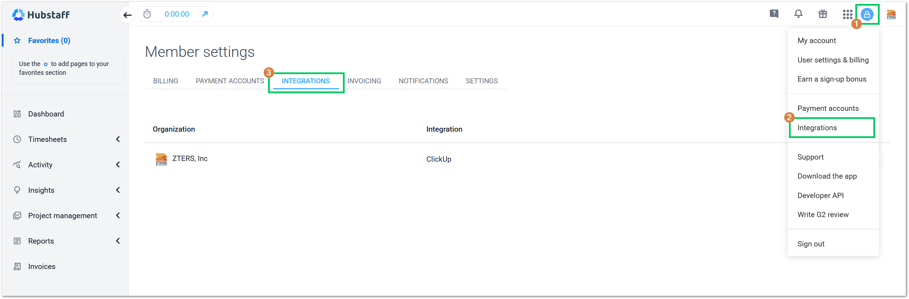

- Validate that the organization is linked to Hubstaff. If it’s not connected, the “Actions” drop-down menu will display the option to Authenticate it.
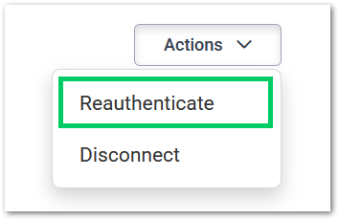

Unlinking projects
Warning: Un-linking and re-linking a project “disassociate” the tasks from the integration. So, if you unlink and relink a project you will end up with two copies of all those tasks, according to the official website.

To unlink projects, simply click on the integrations tab. Then, click the actions menu next to the project you’d like to unlink, and the Disconnect button will appear below.
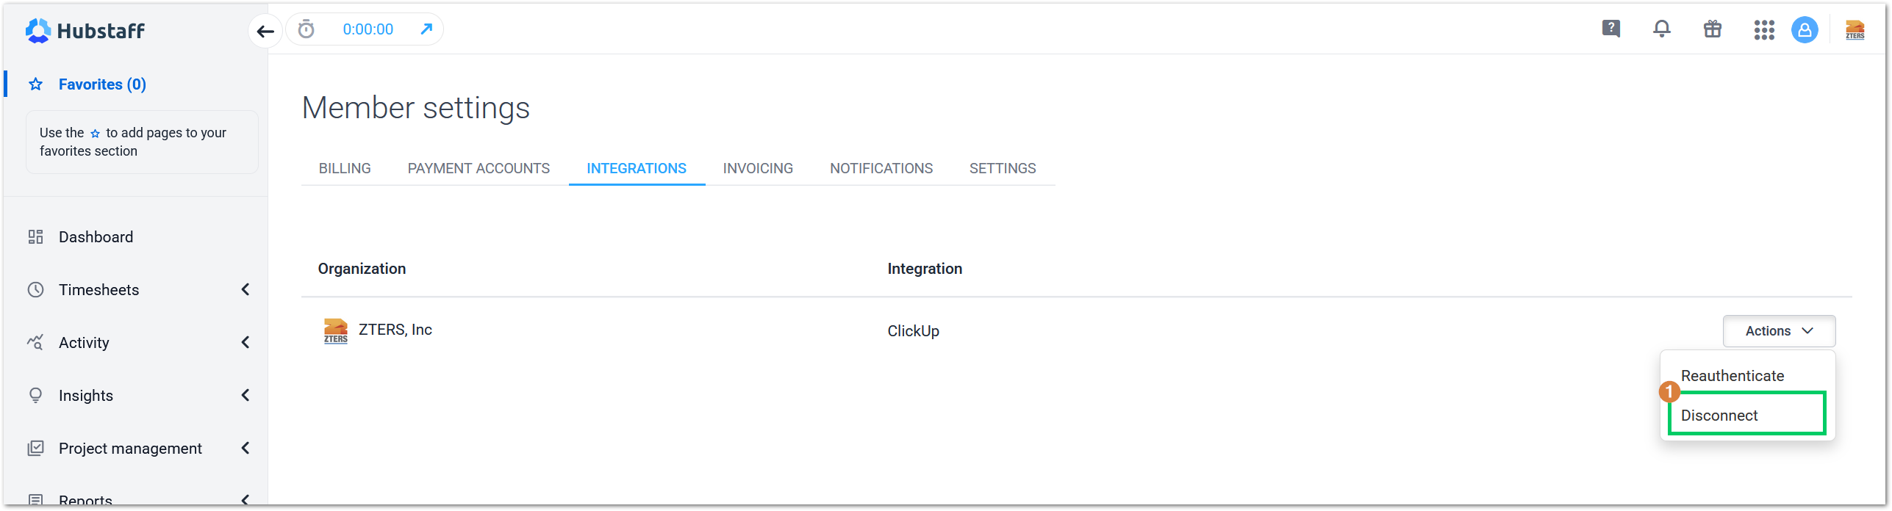
Once you have both your ClickUp and Hubstaff accounts linked, you can start tracking time for the different tasks you’ve been assigned to complete.

TRACK TIME IN HUBSTAFF
Hubstaff works like a standard time clock on your computer. You start and stop the timer whenever needed, so tracking fits naturally into your workflow. Proof of work (screenshots, activity tracking, app/URL usage) is captured only when those features are enabled, and you have the timer running. To track your time in Hubstaff, follow the next steps:

Use Hubstaff desktop to track your time
- Download the Hubstaff desktop application at https://hubstaff.com/download and install it on your computer.
- Log into Hubstaff with your ZTERS account.
- Search for your tasks in the left-hand panel of the Hubstaff desktop application. Most of your tasks will be in the Projects section, depending on your role.
- Select the “play/start” button next to a task to track time. The time tracked will then appear back in ClickUp task activity (as comments or time entries) depending on sync frequency.
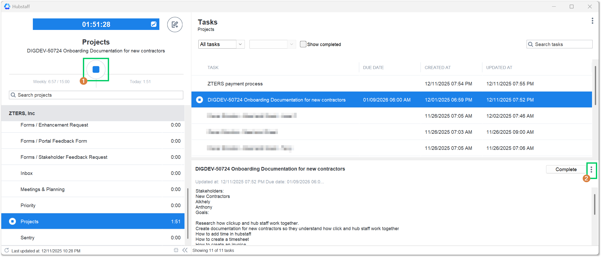
- Check the task in ClickUp by selecting the open task button, using the three (3) dot menu, on the left side of the window.
- Once your task is opened in ClickUp, you can manually change the card status according to the workflow for it.
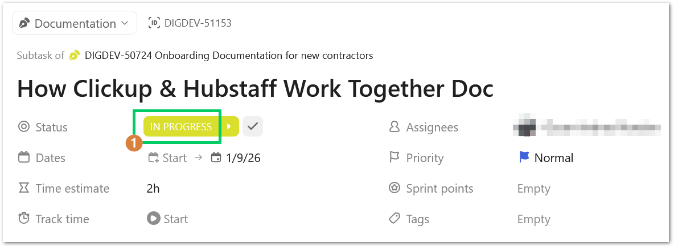
Warning: If you select the “Complete” button in Hubstaff desktop, the card task will automatically change to closed in ClickUp and will disappear from your tasks in Hubstaff. Keep this in mind, if you don’t want to finish the task yet.

Know what’s being tracked
Hubstaff is built to be fully transparent. You will receive notifications whenever the timer starts or stops and when screenshots are captured, ensuring you always know exactly when Hubstaff is active. The Hubstaff Dashboard gives users and managers a quick snapshot of productivity, time worked, and activity levels. To see it, follow the steps below:
- Log into your Hubstaff account
- Select the Dashboard.
Tip: If your Hubstaff dashboard does not display anything, you will need to start tracking time to see some data on the screen.

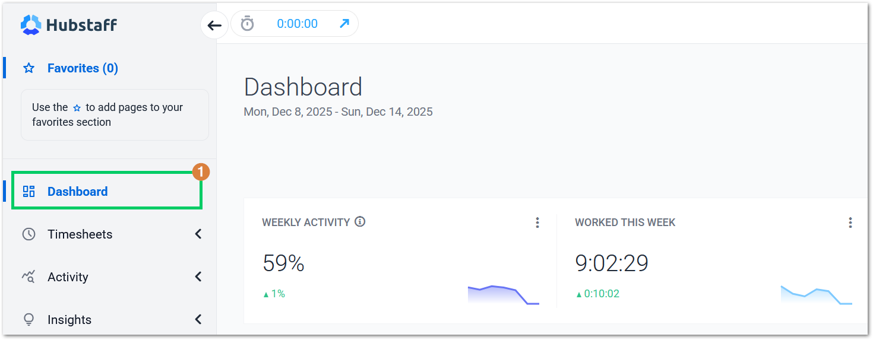

- Select the Timesheet option and check the details of every one of your time entries in the system.
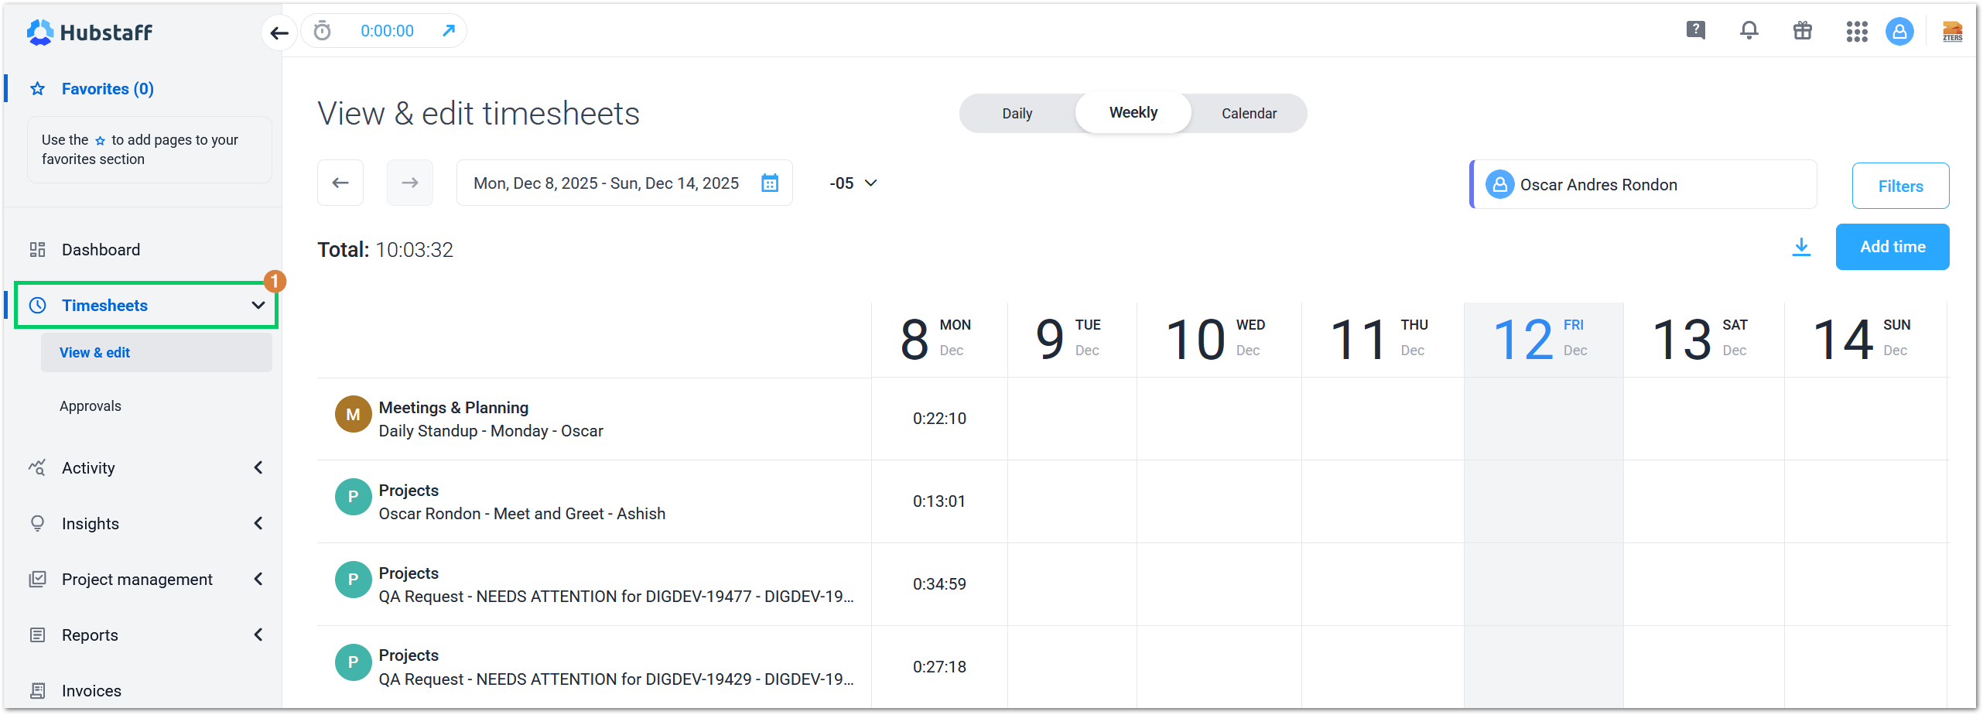

APPROVAL SIGNATURES
Digital signature blocks below are formatted for DocuSign / Adobe Sign.
Role | Name | Digital Signature Block | Date (dd/mm/aa)
Digital Development Manager | Anthony Bures |  | 09/01/2026

--- END OF THE DOCUMENT ---

